Assignment 2

1.

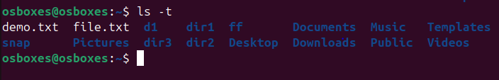

2.

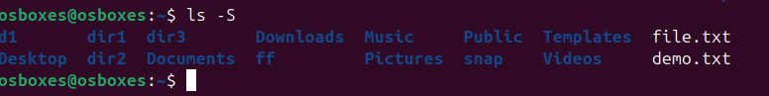

3.

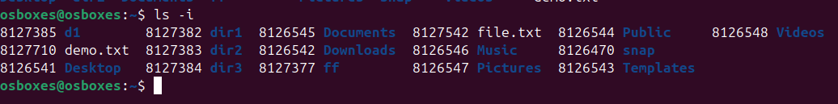

4.

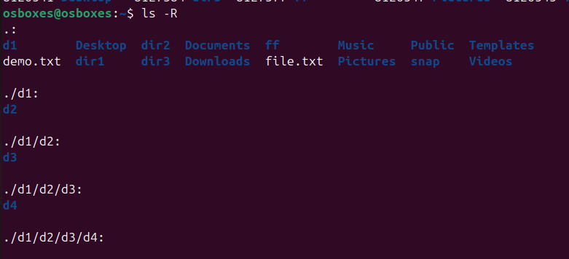

5.

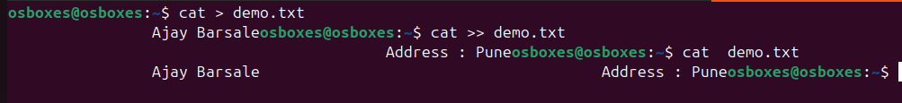

6.

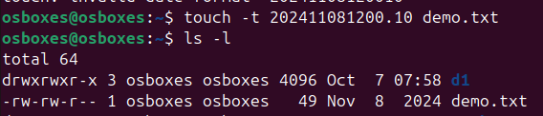

7.

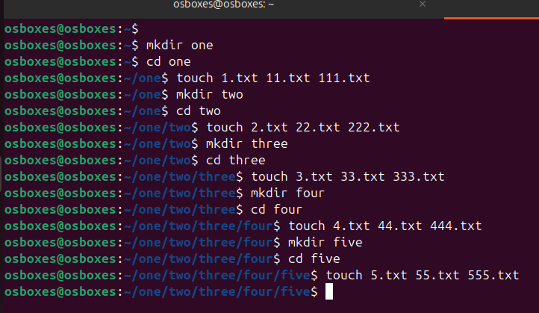

8.1

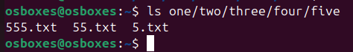

8.2

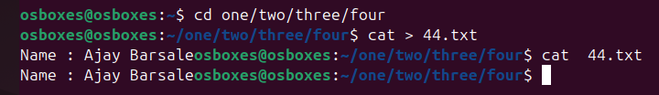

8.3

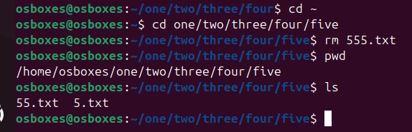

8.4

C:\Users\LENOVO\Pictures\assgn2\8.4.PNG

8.5

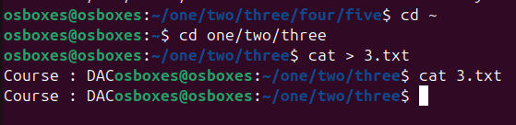

8.6

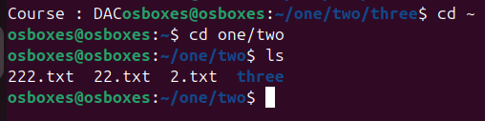

8.7

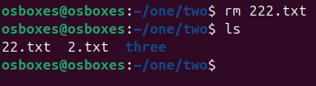

8.8

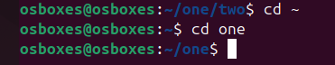

8.9



8.10

C:\Users\LENOVO\Pictures\assgn2\8.10.PNG

8.11

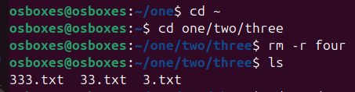

8.12

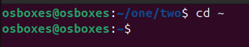

9.

